**Demonstrate how file uploads are handled in AutoIT.**

Till the browser level we use selenium web driver to automate the test.

when we click the upload button the focus shifts to the file manager in windows.

From here we use auto it to automate the test at windows level.

Open autoitinfo and use the finder tool to see the title class and instance of the window

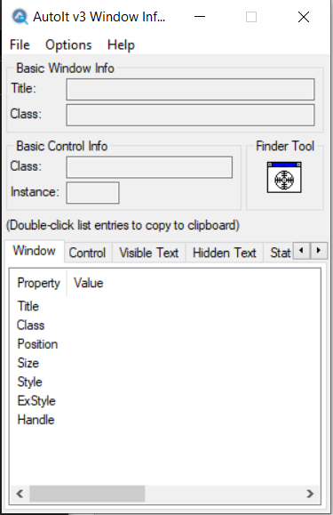

We use editor to write scripts that helps us to select the file which we want to upload.

Then we save the file and name it as <name>.au3

Now we open aut2exe application where we convert au3 file to .exe

We select the file and click on conver.

Now we use the exe file and run it using

Runtime.getRuntime().exec(“<path of the exe>”);

Then we switch to the browser and click on upload using webdriver.